**ASSIGNMENT 9:RISHABH GAUR**

Q1. Write python program:-

1. Create a class named circle constructed by a radius and 2 methods which will compute the are and perimeter of the circle.
2. Create a class named ‘rectangle’ constructed by a length and a width and a method which will compute the area.
3. Create objects of class circle and rectangle and invoke functions; take input from user; use documentation strings; use initialize.

OUTPUT:-

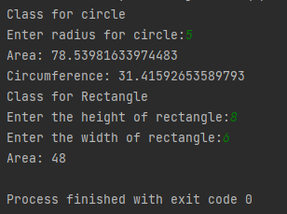

Q2. Create a class ‘student’ with:-

1. Instance attribute: sid , name and marks(in 5 subjects)
2. Functions:

Show details

Compute total marks

Input details

Display grade

A:450-500

B:350-450

C:200-350

D:below 200

OUTPUT:-

